H.T No
Regulations:
A17

Sreenidhi Institute of Science and Technology
(An Autonomous Institution)
Code No: 6EC11 Date: 30-Aug-2021 (FN)

B.Tech IV-Year I- Semester External Examination, Aug/Sept - 2021 (Supplementary)
SOFTWARE AUTOMATION AND TESTING (CSE and IT)

Time: 3 Hours Max.Marks:75

Note: a) No additional answer sheets will be provided.
b) All sub-parts of a question must be answered at one place only, otherwise it will not be valued.
c) Missing data can be assumed suitably.

ANSWER ANY 5 OUT OF 8 QUESTIONS. EACH QUESTION CARRIES 15 MARKS.

Bloom's Cognitive Levels of Learning (BCLL)

Remember | L1 | Apply | L3 | Evaluate | L5
Understand | L2 | Analyze | L4 | Create | L6

 |  |  | BCLL | CO(s) | Marks
1. | a) | Describe some Dichotomies in testing. | L1 | CO1 | [8M]
 | b) | Discuss the standard format for preparing a test plan. | L2 | CO1 | [7M]
2. | a) | Explain with examples the various path testing criteria. | L2 | CO2 | [8M]
 | b) | What are data - flow anomalies? Describe how data flow testing can explore them. | L1 | CO2 | [7M]
3. | a) | Define metric. Discuss in detail the various metrics for source code of a given software. | L2 | CO3 | [8M]
 | b) | Devise a testing strategy taking into consideration a case study like an online shopping cart application. | L6 | CO3 | [7M]
4. | a) | Illustrate the workbench for web based testing in detail with the input and outputs. | L4 | CO4 | [8M]
 | b) | Draw the testing parallels analogous to the software development process. | L1 | CO4 | [7M]
5. | a) | Illustrate with an example the cause effect graph technique. | L4 | CO5 | [8M]
 | b) | How are structured walkthroughs performed? Explain. | L2 | CO5 | [7M]
6. | a) | Apply node reduction algorithm on the following graph:  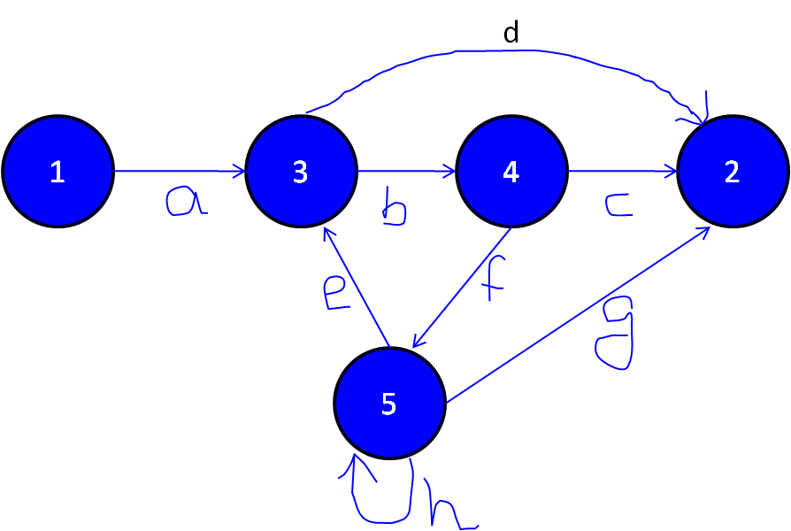 | L3 | CO6 | [8M]
 | b) | Give a brief account on Automated testing tool Load Runner. | L2 | CO6 | [7M]
7. | a) | Draw the complete testing life cycle and explain. | L1 | CO1 | [5M]
 | b) | State a few data flow anomalies. | L1 | CO2 | [5M]
 | c) | Justify the need for establishing testing policy in a software organization. | L5 | CO3 | [5M]
8. | a) | How is an Agile testing process built? Explain. | L2 | CO4 | [5M]
 | b) | Write short notes on CRUD. | L1 | CO5 | [5M]
 | c) | Give the taxonomy of testing tools. | L2 | CO6 | [5M]

-- 00 -- 00 –

